Research Study Arm Event Schedule Mapping Guide

For more information on mapping out arm events, please refer to our user guide. Remember to map out all arms from the start of intervention to the end of study. Even if the events are the same across arms (e.g., same welcome message for both control and intervention), please include them in both arms’ schedule.

Study Summary

Program Name:

Program length:

Target number of participants (ppts):
Goals- briefly describe the goals of your study:

Arms - describe the arm(s) of your study:

Randomization:

Basic

Block

Block Stratification

Stratification - How should participant be stratified (e.g., by age, race)? What should the block sizes be? For help determining block sizes, read our user guide on randomization.

Messaging

Message Carriers (i.e., Verizon, T Mobile, etc.) require Way To Health to seek approvals for each campaign (text messaging program), that we offer. Approved campaigns’ messages are less likely to be flagged as carrier violations than unapproved campaigns’ messages. They recently switched to a manual 3rd party review system, and this is creating longer delays between when we request campaigns and when they are approved. Our current approval timeline is about 3-5weeks, but this process can take longer.

To register your campaign, we need the following info:

A campaign description:
Example:
The XX Study is designed to conduct a randomized clinical trial to test the effectiveness of a digital health intervention versus usual care to improve XX management and patient activation.

Your campaign description:

How do end-users consent to receive messages?
Example:
“Penn Medicine patients consent to receive text messages about research and clinical monitoring programs that may benefit them when they review and sign the Penn Medicine Notice of Privacy Practices (https://w2h.us/QaW7k). If they are selected for this particular program, they receive the a message asking them to additionally opt into the program by signing a consent form (see here: LINK TO CONSENT FORM). Participants can choose to decline to participate via the consent form and may opt-out at any time by texting BYE.
Participants do not have to participate in this study and do not have to join this study to receive treatment.”

Your consent process:

Gamification
If your program does not use gamification, please skip to the next page.

For each arm, please specify:
- What are the rules of the game?
- How long is the gamification portion of the intervention?
- Are their goals ramped or fixed? If ramped, what is the schedule?
- Cohorts
  - If yes, what are the cohort sizes?
  - Is yes, is there a team representative for the cohort?

- Point Schema
  - Loss or Gain
    - If loss, how many points do they start with each week?
    - If gain, how many points can they earn each week?
  - What metric or behavior drives points (step goal, BP submission, etc.)?
  - What is the threshold for losing/gaining a point e.g., "they lose a point (or points) if they don't meet their goal" or "they gain a point for every BP submitted”?
  - Are the points individual or cohort-owned?

Devices
Programs can use devices to collect data (i.e., scale, pedometer, pill bottle, etc.).

If your program does not plan to use a device, please skip to the next section.
Example:

Name | Start/ End  What day should the data collection start? When should it end? | Repeat  Should data collection repeat? (Tip! Typically occurs daily). Repeating- by days or weeks? How many times should the data collection repeat? | Goals  Are there goals for the participant to meet?
i.e., Fitbit | Start  End | Daily for 64 weeks | Participant steps > 7000 steps = met goal  Participant used their inhaler 2X = met goal

Devices

Name | Start/ End | Repeat | Goals
Start
End

Start
End

Start
End

Messaging
Programs can send one-way messages to participants from the study team via text and or email or voice calls. For bidirectional messaging, see Conversations

Example:

Information | Message Content | Date/ Time/ Repeat
Name:  Welcome  Arms: All  Method:  Text | Congratulations on starting in the XX Study! Today is the first day of the study. Please use your Fitbit throughout the entire day including while you are sleeping and strive for your goal of STEP_GOAL steps per day. | Day 1  10:00 AM  No repeats

Messaging

Information | Message Content | Date/ Time/ Repeat
Name:
Arms:
Method:

Name:
Arms:
Method:

Name:
Arms:
Method:

Name:
Arms:
Method:

Name:
Arms:
Method:

Conversations

Programs can engage in bi-directional conversations with participants. These can be configured to trigger specific outcomes or logic depending on how a participant responds and can be scheduled for a particular date and time or initiated when a participant texts in a keyword. You can map out conversations using spreadsheets, through power point, or by using the online platform, Mural. Inform the implementation lead if you want to use Mural and they will share a copy the Mural Conversation Template (view only) with you.
Below is an example from the Mural platform:

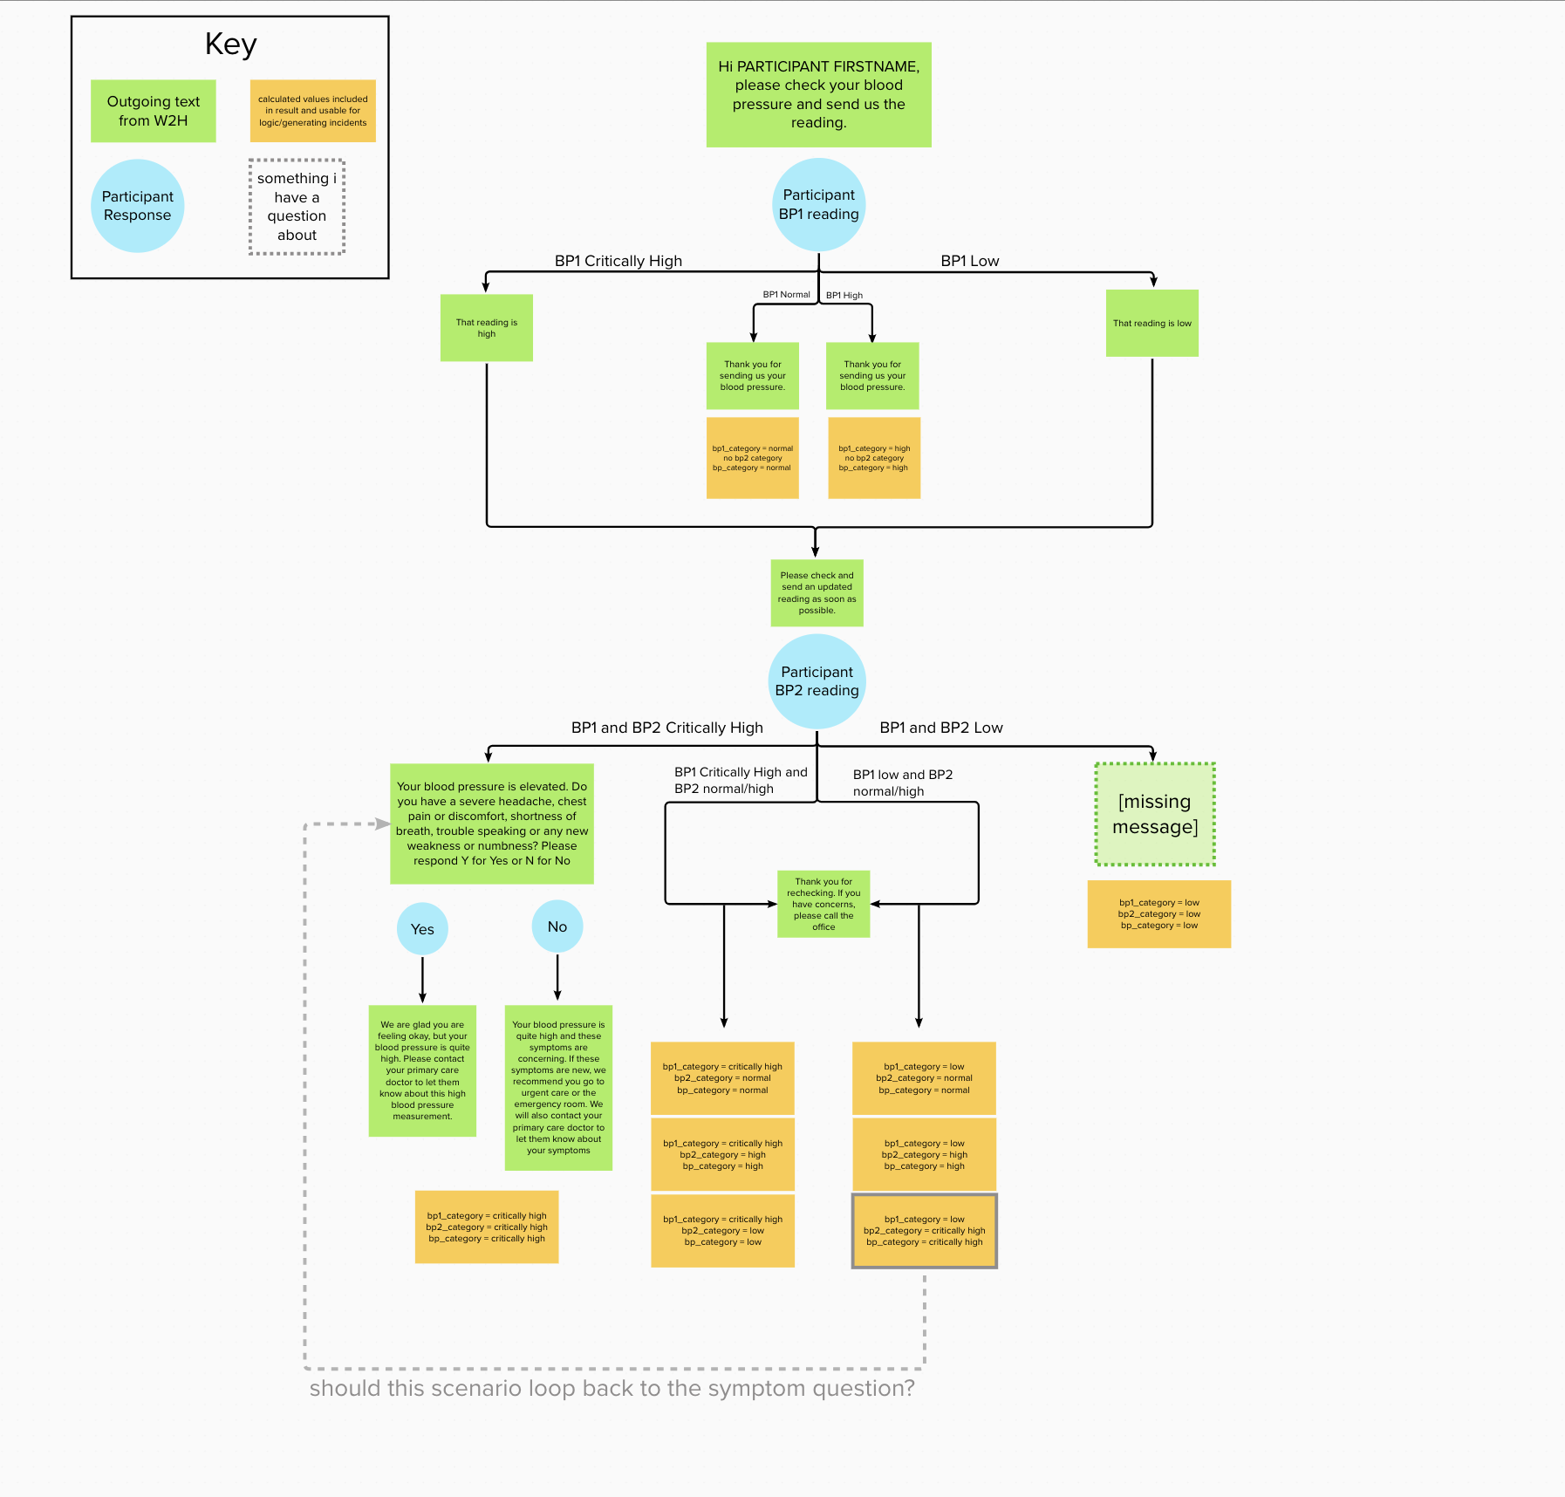

Conversations

You can also map out your conversations in a spreadsheet, like below.

Example:

Conversation | Outgoing Texts | Date/ Time | Repeat? | Outcomes | Reminders  Y/N
Daily Check in  All arms | Good morning PARTICIPANT_FIRSTNAME. This is your daily check-in! How are you feeling today? Reply:  1 - Better than usual  2 - Same as usual  3 - Worse than usual | 9:00 AM – 12:00 PM | Repeat every day for 245 days | IF ppt responds with 3:  Generate Worse Incident  If no response:  Generate No Response Incident | IF Daily Check in conversation is incomplete at 11:00 am, text:  Hello, PARTICIPANT_FIRSTNAME, please complete your daily check in.
Response actions
1 or 2 - Thanks for letting us know. We will check back with you next business day. Please text back "CALL" if you need to speak with a member of your care team, and they will get back to you as soon as possible.

3 - “I’m sorry to hear that. A care team member will be calling you within 30 minutes.”

Conversations

Conversation | Outgoing Text | Date/ Time | Repeat? | Outcomes | Reminders  Y/N
To split a row, right click your mouse on the cell,
choose “Split Cell” from the menu and then enter columns: 1, rows: 2.

Surveys
Plan to attach a separate document for each survey you wish to administer. In this document we will need you to label each question with a unique question ID. The Outcomes column refers to whether a particular response will trigger an event or an incident.

Example:

Survey Name | Method | Date(s) | Time | Messaging | Outcomes | Reminder  Y/N
Pain History | Text | Baseline  6 months  12 months  18 months | Participant Start | Hello, PARTICIPANT_FIRSTNAME, this is the XX team. Please complete this survey, SURVEY_LINK about your pain. Please contact your study team if you run into any issues or have any questions. | If answer yes to question #10 (Question ID = pain worse) generate Incident: Pain Worse.)  and generate Survey Nonadherence Incident | If incomplete for 2 days trigger Survey Reminder text:  Please remember to complete your PROMIS survey at your earliest convenience.

Surveys

Survey Name | Method | Date(s) | Time | Messaging | Outcomes | Reminder  Y/N

Incidents
Incidents are alerts generated by participants sent to program staff and clinicians. They can be triggered by the way a participant answers to surveys, conversations, and keywords. Participant data, like a high Blood Pressure reading from an Omron Digital BP cuff, can also trigger an incident. Way To Health allows program staff to decide: 1) who on the team will receive the incident, 2) when an incident is sent to staff, and 3) how it is delivered (i.e., email, SMS, and for Penn programs, Epic In basket).
*The Way To Health platform also generates system incidents (i.e., software, hardware) that are already set up for every program.

Example:

Incident Name | Incident Language | Schedule / Method | Recipient
Survey Nonadherence | PPT_FIRSTNAME has not yet completed their Pain survey. Reach out via email to see if they need assistance. | Send once a week via email | Research Coordinator
WORSE | PPT_ID has indicated that their condition is worse. Arrange to call them by end of next business day. | Send immediately via email | Program Manager

Incidents

Incident Name | Incident Language | Schedule/ Method | Recipient

Keywords
When a participant texts in a keyword a program can send a response and or trigger an outcome.

Example:

Keyword | Response | Outcomes
Call | During Business Hours:  I’m sorry to hear that. A care team member will be calling you within 30 minutes.  After Hours:  Our care team is out of the office. Call your Primary Care Physician/Pulmonologist. If you are having extreme difficulty breathing, please call 911. | Generate Call Incident or Call (off hours) Incident
Bye | During Business / After Hours:  Thank you, we will unenroll you from this program. | Generates Bye Incident

Keywords

Keyword | Response | Outcomes

Personnel
Learn more about study roles and permissions here. If your program has multiple sites and you need to control which site has access to a participant’s data, include the name of the site in the Access Group column.

Name | Email | Phone Number | Role | Epic ID | Access Group

Notes

Use this space to document any notes you think will assist the implementation lead while working on this project.

